# Advanced Internet Technologies - Project

Point of interest (POI) visualizer

Team

**Muslim Chochlov**

**Ilona Kuzmickaja**

1. **Problem identification:**

When a traveler visits a city, usually follows a map to locate himself and decide where to go. However, most times the map only shows a layout of the organization of the city and does not include specific information about street-level likeness of a place (i.e. buildings, monuments). In consequence, sometimes even having a map does not fully provide enough information about the place a traveler is in front of.

1. **Solution and description of the project:**

Augmented reality is a technology which integrates real and virtual information in real time to expand human senses, by providing additional information that cannot be seen or felt in the real world.

By integrating augmented reality technologies to the operation of a regular mobile device, it is possible to display additional information about a place (e.g. interesting points in a city) when the user captures it using the device’s camera. Then, such capture can be processed using augmented reality libraries.

This project consists of an Android application that by using the phone’s camera and augmented reality libraries, will display the name of the Points of Interest (POIs) around the user, as the phone is rotated left or right. If we're heading 30 degrees in another direction, it should show us the nearest POIs that are located in that direction.

1. **Target users:**

Travelers, or anyone who needs to find out information about places in the nearby.

1. **Used technology:** 
   * **Mixare.-** Free open source augmented reality browser, which is published under the GPLv3. Mixare is available for Android. It works as a completely autonomous application and is available as well for the development of own implementations.
   * **Google Maps.** Array of APIs that let the developer to embed robust functionality and everyday usefulness of Google Maps into an stand-alone website or applications, and overlay own data on top of them.
2. **Architecture overview:**

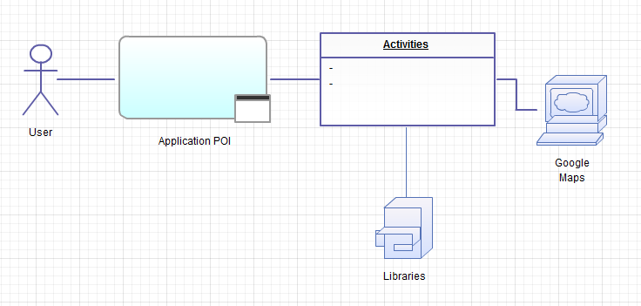

1. **Features:**

* Oriented locations. Each location is identified by its name and angle to which the phone must be oriented so the location appears in front of the camera.
* Smooth Animations. You will find that POIs have a very smooth movement, and you can stop and capture each one on the screen.

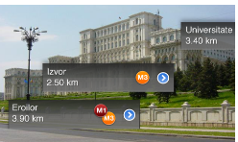

Picture 1. POI visualization

1. **Effort:**
   1. **User stories**

***User story 0:*** Existing app/services analyzation

***Estimation time:*** 15 h

***Description***: <..>

***User story 1***: Application start

***Estimation time:*** 12 h

***Description***: When user launches the application, camera starts populating the entire screen

***User story 2:*** Exiting application

***Estimation time:*** 9 h

***Description***: When user presses exit button, dialog asking user confirmation should popup. On exit application should clear after itself that is close connections/free resources etc.

***User story 3:*** Augmented reality objects

***Estimation time:*** 24+ h

***Description***: Objects that are shown in camera and which are in certain radius should be given an augmented reality titles. Title is displayed on the screen in front of the object

***User story 4:*** Changing phone location/angle

***Estimation time:<..>***

***Description***: If phone location or angle is changed augmented reality titles on the screens should be changed accordingly to reflect correct real objects.

* 1. **Tasks**

|  |  |  |  |  |  |  |  |  |
| --- | --- | --- | --- | --- | --- | --- | --- | --- |
| User story No. | Task No. | Description | Assignee | Status | Deadline | Estimated time (hours) | Spent time (hours) | References |
| 0. | 1 | Get current location using GPS. | Ilona | Done | 2011.10.14 | 7 | 8 | 3.1 |
| 0. | 2 | Analyze mixare browser | Muslim | Done | 2011.10.14 | 8 | 8 | - |
| Total per user story: | | | | | | **15** | **16** |  |
| 1. | 1 | Launch camera when app starts | Muslim | In progress | 2011.10.21 | 12 | ? | 2.1 |
| Total per user story: | | | | | | **12** | **?** |  |
| 2. | 1 | Implement app close and confirmation dialog | Ilona | Done | 2011.10.21 | 9 | 6 | - |
| Total per user story: | | | | | | **9** | **6** |  |
| 3. | 1 | Find a service/ a way to get coordinates of a given current location. | Muslim | Assigned | 2011.11.04 | 12 |  | 3.2 |
| 3. | 2 | Analyze which objects are getting in scope of the camera. | Ilona | Assigned | 2011.11.04 | 12 |  | - |
|  |  |  |  |  |  |  |  |  |
|  |  |  |  |  |  |  |  |  |
|  |  |  |  |  |  |  |  |  |
| Total per user story: | | | | | | **24** |  |  |
|  |  |  |  |  |  |  |  |  |
|  |  |  |  |  |  |  |  |  |